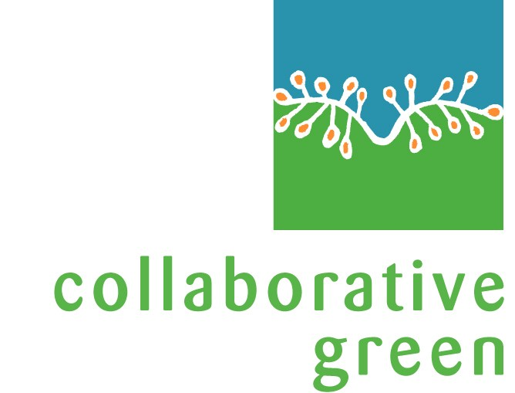
Erinellene Sanborn
P.O. Box 3571
Taos, New Mexico 87571
(505) 770-2991
erin@collaborativegreen.com

Career Summary

Erin Sanborn has twenty-five years of organization development and international conflict resolution experience. She has a solid background in management and leadership coaching. Her work crosses all sectors: nonprofit, corporate, public, and community. She has specific expertise in designing public-private community partnerships. Erin also has over a decade of work in the inter-cultural and international arenas. Her professional passion is to work with visionary people and organizations.

Professional Experience
- Partner, Collaborative Green, current
- Mother, farmer and part time consultant, Creative Partnerships International, 2004-2007.
- Grants Officer, Taos Community Foundation, 2004-2005.
- Director of Program Development, Taos Business Alliance for Economic Development, 2002-2003.
- Program Manager, Transition & Change Management, Intel Corporation, 1999 – 2000.
- President and Founder, Creative Partnerships International, 1991 – 1999,
- Senior Associate, Interaction Associates, Cambridge, 1988 - 1991.
- Independent Facilitator and Mediator, San Francisco, 1983 - 1988.

Client Short List
- The Alliance for Community Care, 1995-1998, formed a countywide, multi-agency process that established an integrated mental and behavioral health care delivery system resulting in a four agency merger and an appointment of a new CEO.
- California State Assembly’s Democratic Caucus, 1995, consultant on the development of a values based political platform and facilitation of the Demopcratic caucus.
- Environmental Protection Agency, Washington, D.C., 1988, design and facilitation of a working conference for scientists and policy makers that developed a framework to qualify wetlands as an ecosystem, thereby, enabling the creation of policies to protect these lands.
- Geographic Expeditions, 1997-2000, consultant to the organization’s yearly strategic planning process involving Board members, employees and customers.
- Institute for Intercultural Training Services, 1995, an Organization Effectiveness consultant and an Intercultural Communications specialist offering courses in Intercultural Systems Thinking.
- Intel Corporation, Assembly Test Manufacturing, 1997-1999, an organization development consultant increasing manufacturing agility throughout the global assembly/test manufacturing division. In 1999-2000, employee of the corporation as the Transition and Change Manager with the result of implementing Intel’s Advanced Planning System.
- International Alert, (a conflict resolution NGO), 1992, consultant on the development of the organization and its move from Oslo to London. Manager for three of the organization’s projects: HURIDOCS, a conference on the computer networking of human rights organizations across the world, a commission for the International Peace Association’s conference in Kyoto, Japan, and a year-long program called the “Moscow Conflict Resolution Training Seminar” co-sponsored by the United Nations University and the Russian Academy of Ethnic Studies.
- Massachusetts Institute of Technology, 1996-1997, an internal Organization Development consultant implementing three years of re-engineering work throughout the Student Services and Information Systems organizations.
- Massachusetts Institute of Technology’s The Center for Organizational Learning, 1996, a coordinator of the redesign process for one of the Sloan School of Management’s sponsored research centers, The Center for Organizational Learning, now the Society for Organizational Learning, SOL.
- Mt. Auburn Hospital, 1988-1990, consultant on a project to address the lack of employee retention. The project evolved into an organizational redesign process which improved work flows, services and roles and responsibilities for the hospital staff.
- Next Generation Economy, Inc., 2001, consultant to two economic development clusters; Tourism and Transportation, and one organizational committee; focusing the work to accomplish its goals.
- Norsk Hydro, Department of Health, Environment and Safety, consultant in the development of a multi-stakeholder strategic planning process coordinating the company’s environmental activities in alignment with the results of the Untied Nations conference on the Environment and Development in Rio de Janeiro.
- Pacific Bell, 1984-1986, a consultant on a team that re-designed the company after divestiture from AT&T. The result was a restructure of the organization’s work flows, structure and leadership develop training.
- Palm Beach County School District, 1990-1991, project manager, consultant and trainer on a county-wide, public-private partnership to achieve the state goals of “Quality Education.”
- SAS Flight Academy, 1990-1994, consultant managing an organization-wide strategic planning process as the Flight Academy became an independent business from Scandinavian Airlines. Consultant for ongoing leadership coaching, strategic planning, union/management negotiations, and team development services. In 2000, manger of two departments which were merged until a permanent director was hired.
- Santa Clara County Department of Transportation, 1986-1988, facilitator on a team that developed a county-wide collaborative planning process which developed an integrated transportation system throughout the county.
- South County Housing, 1995-1996, consultant to a community-wide strategic planning process regarding the future of affordable housing. Coach for the Executive Director.
- State of New Mexico's Children's Cabinet, 2008, event facilitator.
- Taos Communications Corporation, KTAO, 2002 – 2004. Consulting to the company's leadership in developing a new strategic plan.
- Taos Chamber of Commerce, consultant to the board of directors’ at the annual retreat which developed a strategic focus and draft plan, 2002
- Taos Community Foundation, 2001-2004, Committee member, project facilitator, grants officer.
- Town of Taos, The Taos Project facilitator 2001-2002, community roundtable facilitator and the proceedings author in 2002. Employee surveys completed for the Town Manager in 2003
- United States House of Representatives and the United States Congress, 1992, facilitated the annual Democratic caucus and the task force on “National Security and Defense.”

Languages
- Spanish, fluent
- Norwegian, intermediate
- French, intermediate

Education
Bachelor of Arts, “International Conflict Resolution and Organization Development,” World College West, Petaluma, CA. 1984

A degree in International Conflict Resolution and Organization Development did not exist as a Bachelor of Arts degree in 1980. Therefore, in collaboration with the faculty at World College West, an academic advisory council was established to create a fully accredited, interdisciplinary degree. The undergraduate degree included course work from the first Master's degree program in International Conflict Resolution offered at George Mason University, Fairfax, VA. and from the Ph.D. program in Political Science at University of Maryland, College Park, Maryland. The emphasis of the degree was designing different methods and processes to assist people in working together.

Professional Training
- ZERI (Zero Emissions Research and Initiatives), 2002.
- Fifth Discipline’s Core Training Program, MIT 1996
- Conflict Resolution from the Conflict Resolution Network, 1993.
- Licensed to train Interaction Associates' programs in Large Scale Public-Private Partnerships, Facilitative Leadership, Beyond Problem Solving, The Complete Facilitator, and Mastering Meetings for Results, 1983-1992.
- Systems Energetics, from Nancy Post and Warren Bellows, Wharton School of Business. 1987.
- Group Graphics and Exploring the Art of Facilitation, the Grove Consultants International. 1984 & 1986.
- Community Boards Mediation Program of San Francisco, 1983.

Pro Bono Work
- New Mexico First, Facilitator.
- Sustainable Communities/ZERI New Mexico Advisory Board Member.
- Taos County Council of Neighborhood Association, Facilitator.
- Des Montes Neighborhood Association, President.
- America Speaks, Facilitator.
- Santa Fe Arts Initiative, Consultant.
- New Mexico Recycling Coalition, Ex-Board Member.

References

Available upon request.

